1. Management wants to see how much is spent in Shipping Costs across the different
Product Categories and Sub Categories for each Ship Mode. Add a new sheet titled Q1.
Required Components: 1) A table with the Product Categories and Sub Categories listed.
2) Shipping Costs for each Ship Mode. 3) Color the Shipping Costs based on the Product
Subcategory. Using the same data, on a new worksheet titled Q1b, create a circle views
chart. Do you see any outliers? What are they?

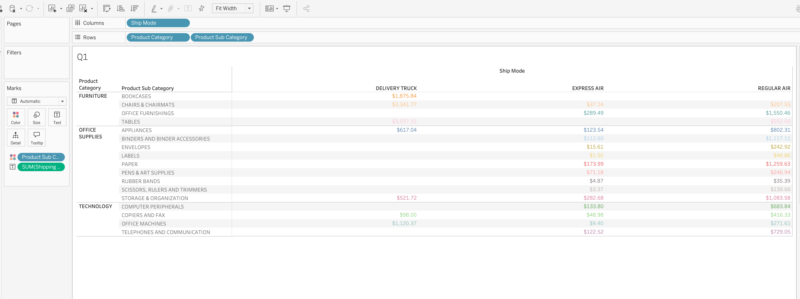

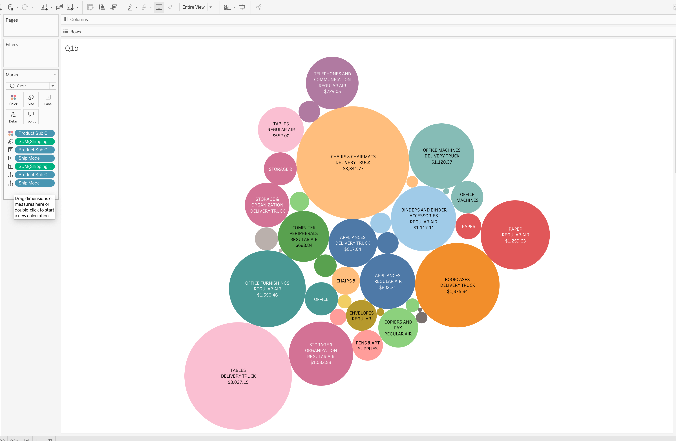

Q1b – Outlier Analysis
Yes, there are noticeable outliers in shipping costs. Chairs & Chairmats ($3,341.77) and Tables ($3,037.15), both shipped by Delivery Truck, have the highest shipping costs. Bookcases ($1,875.84) also stands out. These categories have significantly higher total shipping costs than most other product subcategories.

2. Management is eager to know the Average Sales and Average Discount across the
Product Categories and Sub Categories, using a Bar Chart. Add a new sheet titled Q2.
Required Components: 1) A bar chart to represent the Average Sales. 2) Color the bar
chart using Average Discount 3) Add labels to the bar chart representing average sales
for each sub category. Create a new worksheet titled Q2b. Choose another visualization
to display the data. What is the difference? Is one preferred over another?
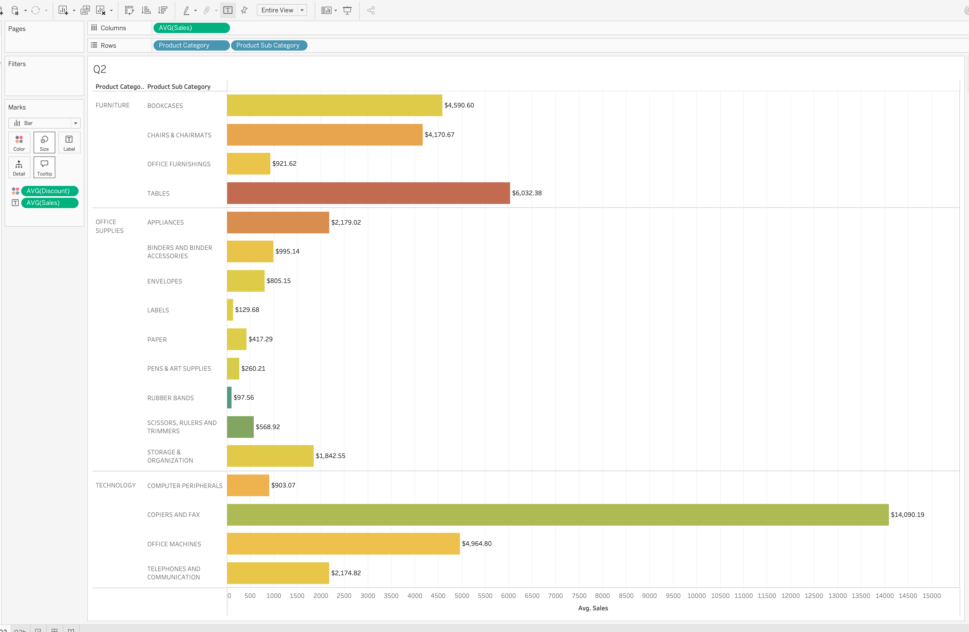
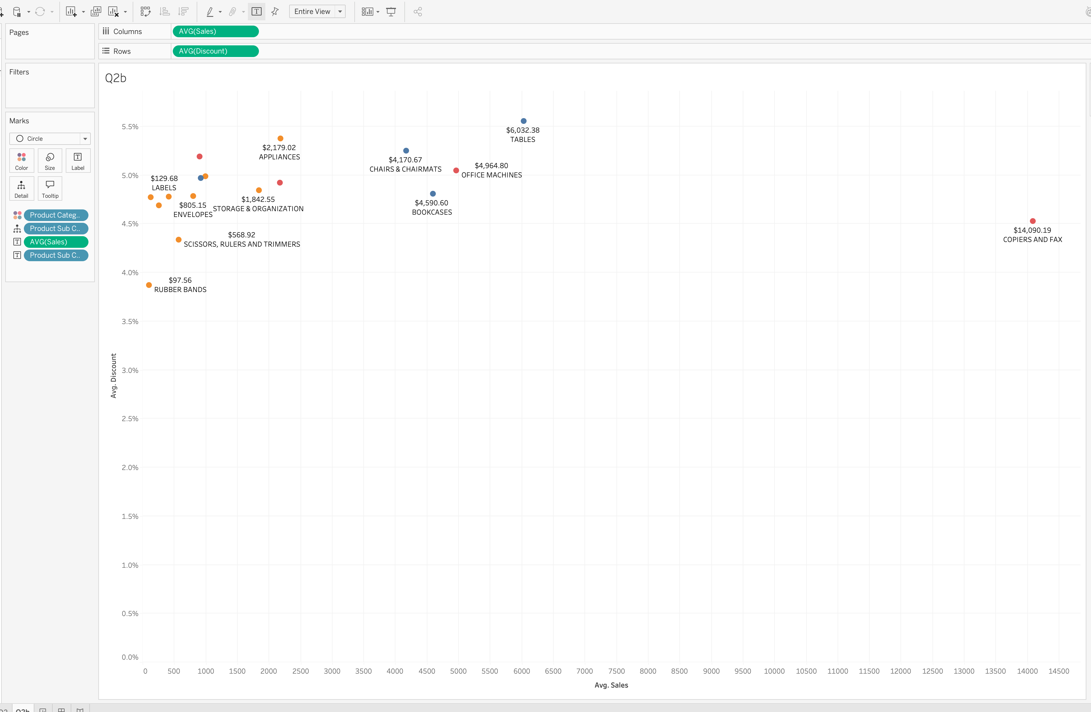

Q2b analysis
The bar chart makes it easier to compare average sales across product subcategories, while the scatter plot shows the relationship between average sales and average discounts. Copiers and Fax has the highest average sales at $14,090.19, with an average discount of approximately 4.5%. I prefer the bar chart because it makes comparing sales across different products easier.

3. Historically the company has provided discounts to their Top 10 customers in terms of
Profit. Using Packed Bubbles, find the Top 10 customers. Add a new sheet titled Q3.
Required Components: 1.) Use packed bubbles to display your results. 2.) Cust id is
represented by color. 3.) Add a filter to filter out the Top 10 customers based on Sum of
Profit 4). Display the Cust id, sum of profit in the circle.

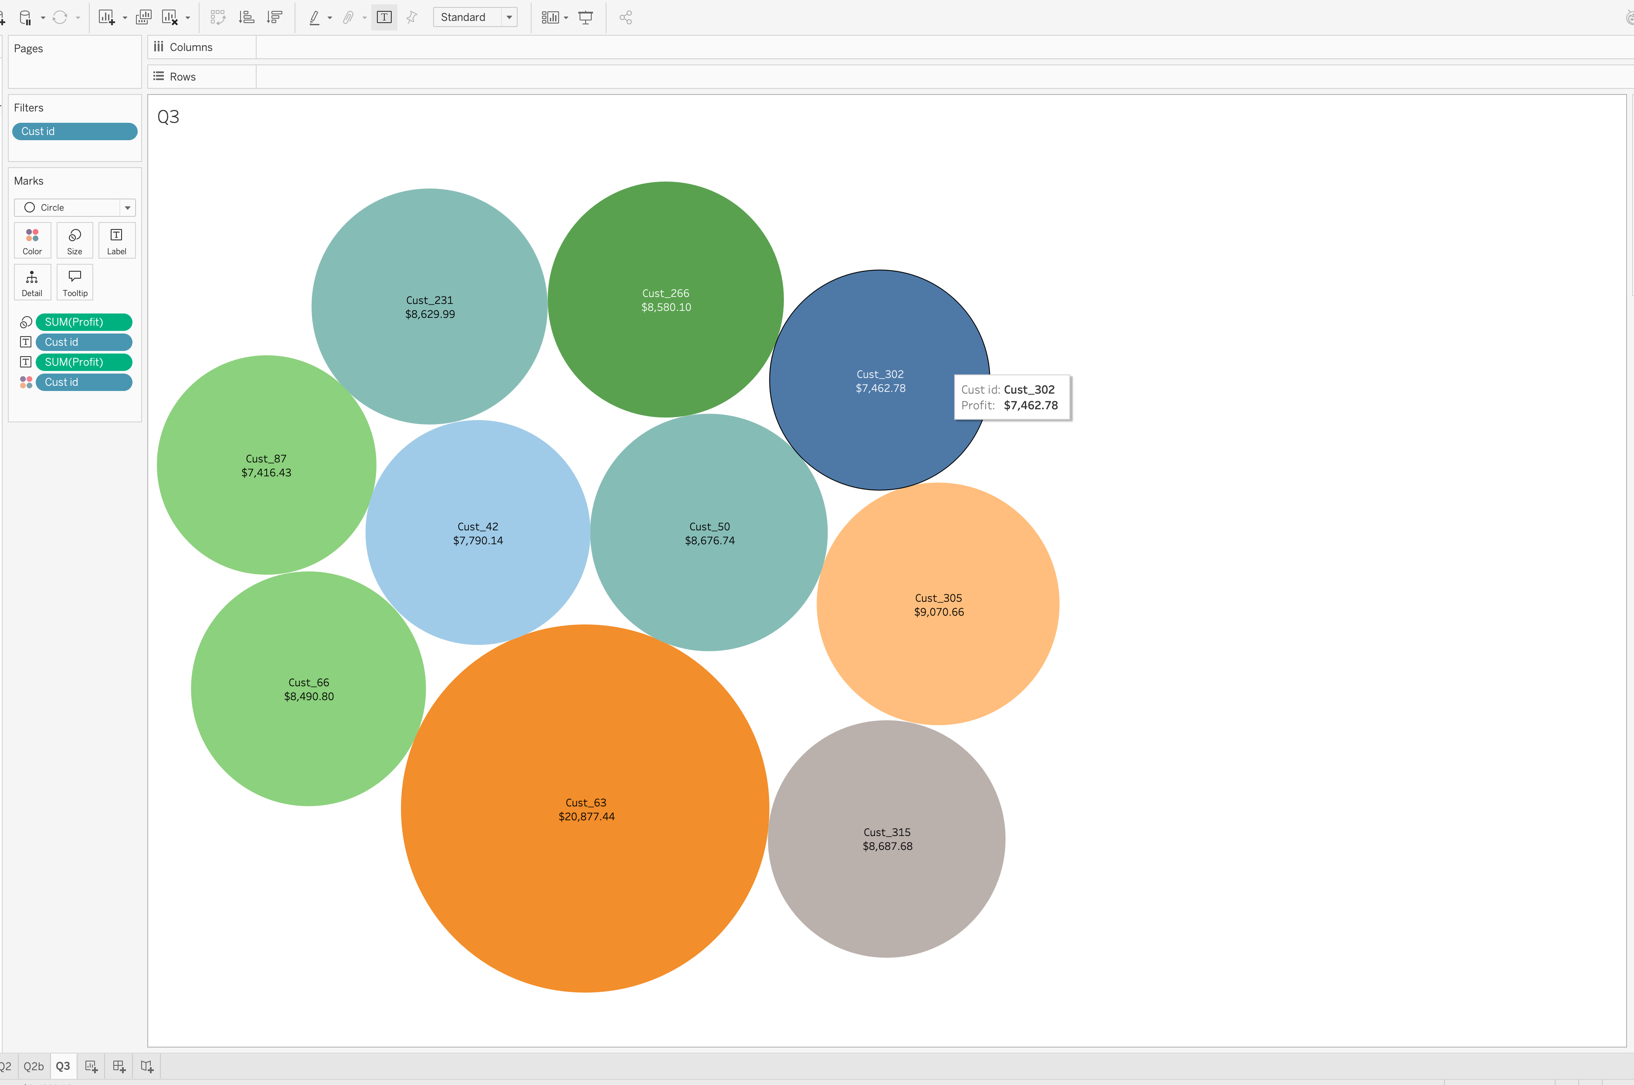

Q3 analysis
The packed bubbles chart displays the Top 10 customers based on total profit. Customer 63 is the most profitable, generating approximately $20,877, significantly more than the other customers. Management should consider prioritizing this customer when offering discounts and loyalty incentives.

4. Management wants to see the proportion of the Product Base Margin across the 3
Product Categories. Use a Pie Chart, display the split of the sum of Product Base Margin
across the Categories. Add a new sheet titled Q4. Required Components: 1.) Use a Pie
to display your results. 2.) The angle of the pie chart is dependent on the sum of
Product base Margin. 3.) Label the sections of the Pie Chart with the Product Category
and Sum of Product Base Margin.

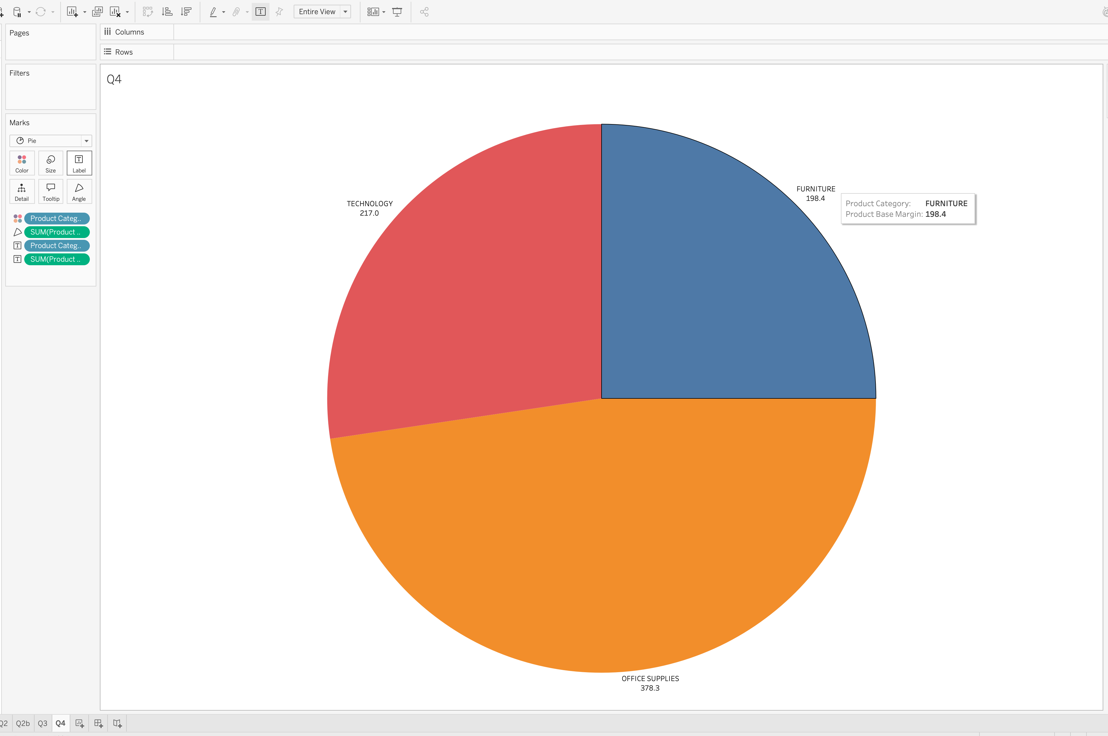

Q4 analysis
The pie chart shows the distribution of Product Base Margin across the three product categories. Office Supplies has the highest total at 378.3 (47.7%), followed by Technology at 217.0 (27.3%) and Furniture at 198.4 (25.0%). Office Supplies represents the largest share of the total Product Base Margin.

5. Management wants to compare product profit and sales by quarter. They want a quick
view by each product sub category. Choose the data visualization to best represent this.
Required Components: 1.) Use a visualization of your choice. 2.) Add labels for profit,
sales, and product sub category. 3.) Add colors. Hint: there are many visualizations
that could be used. Choose one that you like.
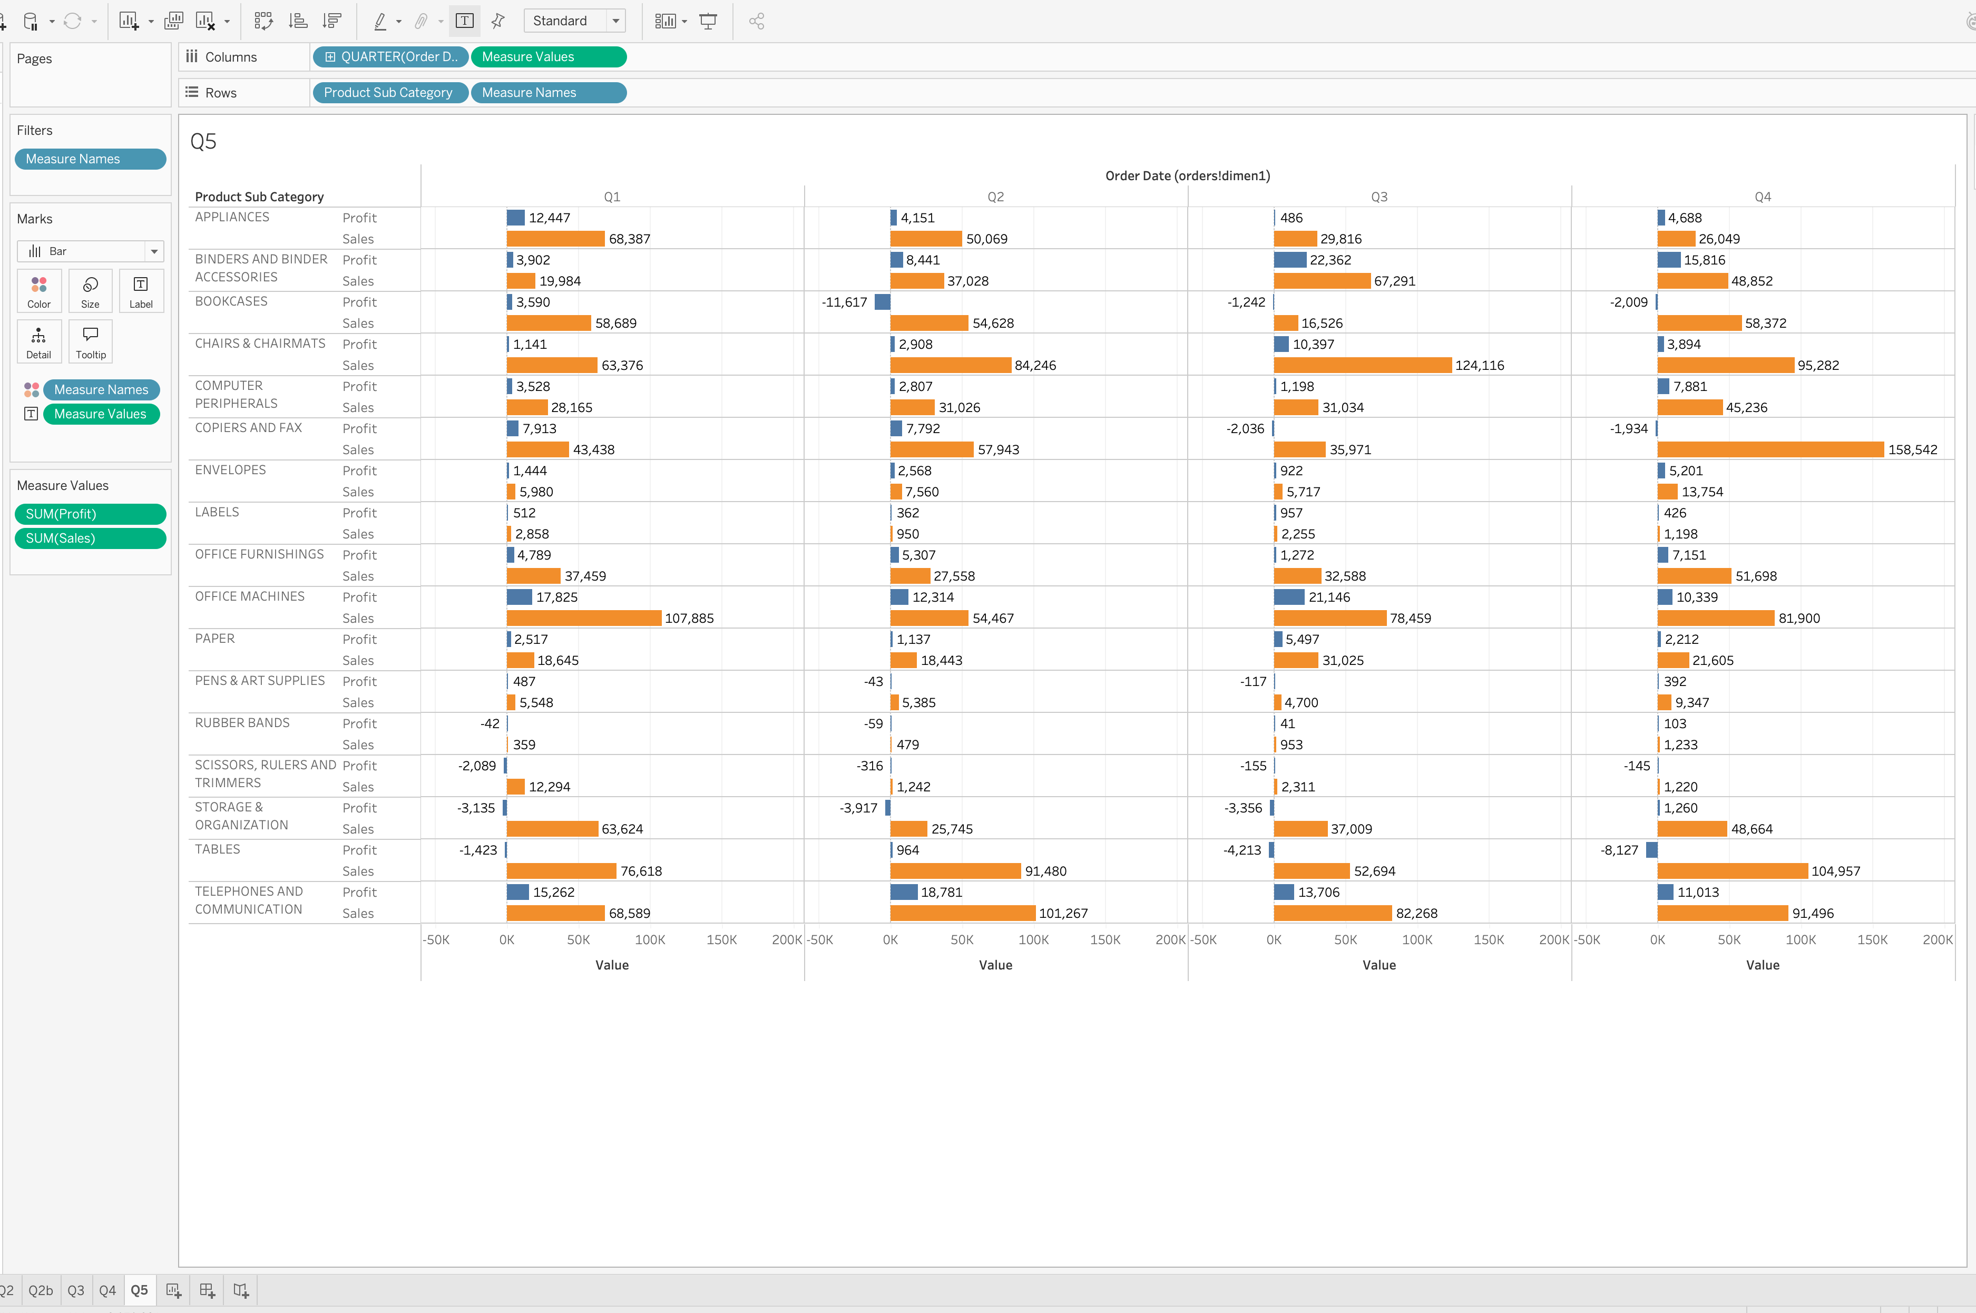
Q5 analysis
The quarterly comparison chart shows differences in sales and profit across product subcategories. Copiers and Fax generated the highest visible quarterly sales at approximately $158,542 in Q4. Binders and Binder Accessories earned a strong profit of approximately $22,362 in Q3. However, Tables experienced a loss of approximately $8,127 in Q4 despite generating substantial sales. This suggests that management should evaluate product profitability rather than relying only on sales revenue.

6. To make the presentation more appealing, put together your visualizations as a
storyboard. Required Components: 1.) Create a storyboard. 2.) Insert a cover page to
highlight what the report is about. 3.) On each page add text to explain the
visualization/findings.

